# Design Work-Michael

* Done

|  |  |
| --- | --- |
| Mechanic | - Moving - Jump (changes model size to fit through gaps) - Transport between planes - Interaction with objects - Rotate individual planes - Temporary invulnerability |
| Level Design | Screen ClippingScreen Clipping   |  | | --- | | Screen Clipping1.Testing level             2. First level | | |
|
| Character | Screen Clipping- Main character - Name: Raven (tentative) - Late teens/early 20’s - Long black hair, covers 1 eye - Emo/Goth inspired - The Veil: glowing cape/scarf - Positive nihilist (what is going on, this is awesome!)  -The Count o Robed wizard figure o Dark Dumbledore o Guide for Raven, appears/disappears |
| Enemies | Ghouls – attached to floor/wall, set movement (back and forth). Kills Raven on touch. Ghost – Floating in the air, with line of sight to Raven begins following her. If line of sight broken, return to spawn position. Kills Raven on touch. Skeleton – Stationary, fixed points in level. Throw bones in set parabola at set intervals. Bones kill Raven on touch. Green Goo – attached to floors/platforms/walls. Kills Raven on touch. Yellow Goo – progressively slows Raven down. If her speed reaches 0, it kills her. (animation pulls her under) |
| Environment Conception | - The Cathedral - Ancient building with dark magic (castle-like) - Mainly stonework - Different colour palette for each plane - Gardens/ other areas - Visuals for when The Veil can/can’t be used |

* To do

|  |  |
| --- | --- |
| Level Design | 1. Second level 2. Final level |
| Enemies | More enemies with different ability. |
| Game story | We need to finish the game plot in next few weeks |
| Interface | 1.Title 2.Main menu 3.Tip element in game |

# Art Work-Samantha

* Done

|  |  |
| --- | --- |
| Character | Conception & static picture |
| Enemies | -Ghouls: conception & static picture -Dangerous Goo: animate resource |
| Environment | -First version of background -3 kinds of walls -Teleportation area with animate -Locked doors -Key |

* To do

|  |  |
| --- | --- |
| Character | Animation resource for every action: -Running animation -Stationary animation -Jumping animation -Invincible animation -Transport animation -Death animation -Talking animation |
| Enemies | -Ghouls: Walking animation -Ghost: Floating animation -Skeleton: Throwing animation |
| NPC | -The Count |
| Environment | -Platform -Lever -The goal |
| Special effect | -Effect of Raven's move -Effect of environment |
| Interface | -Main title -Button -Dialog box -Tip element |

# Music Work-Stuart

* Done

|  |  |
| --- | --- |
| Music | Title theme |
| Effect Sound | - Raven jumping (woosh) - Raven jumping with the Veil (more like a schloop) - Talking (when text appears, go beep beep boop beep) - Ghoul noise (grunts, mostly) - Picking up key noise |

* To do

|  |  |
| --- | --- |
| Music | 3 themes, 1 for each plane OR 1 theme with 3 variations |
| Effect Sound | - Raven walking - Raven teleporting with The Veil - Raven dying (similar to teleporting) - Ghost noise (whatever noise you think a Ghost makes) - Skeleton noise (bone wizzing through The air, landing) - Acidic goop noise - Floor falling out - Pushing a lever - Giant stone structure rotating - Victory sound |

# Program Work-Jonny

* Done

|  |  |
| --- | --- |
| Mechanic | - Moving - Jump (changes model size to fit through gaps) - Transport between planes/change level's layers - Interaction with objects |
| Level Building | Testing level |

* To do

|  |  |
| --- | --- |
| Mechanic | - Rotate individual planes - Temporary invulnerability |
| Level Building | Finish 3 levels in 3 weeks |
| Interface | -Main menu -Setting -Save data -Game dialog and story telling |

# Others-Yang

* Game content mind map

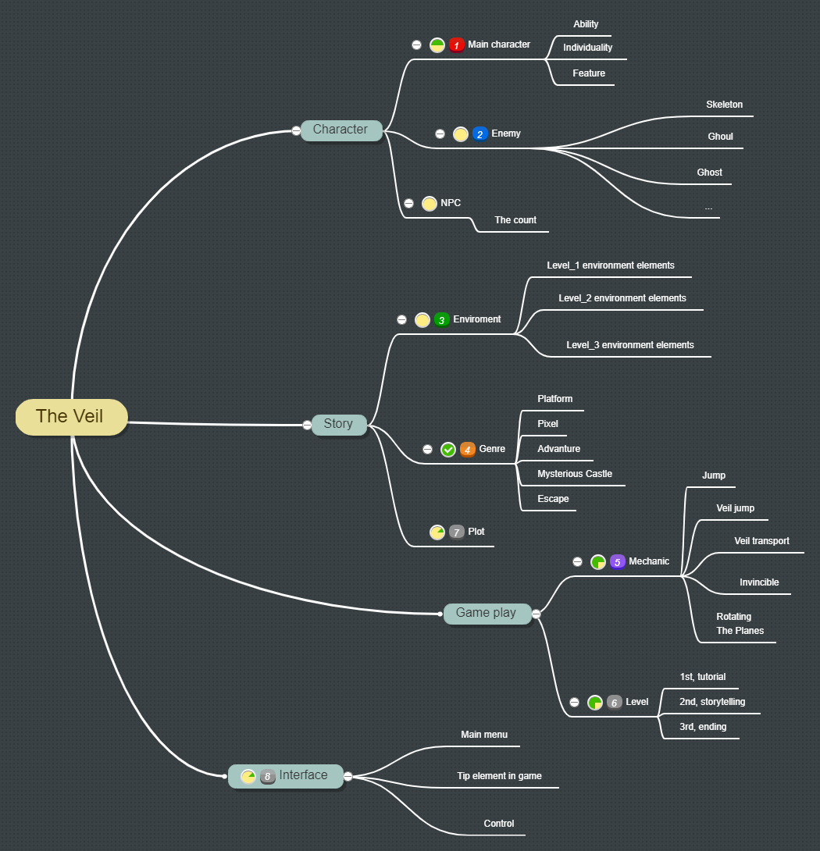

* Work flow

